A SAMARY REPORT ON MALARIA CONTROL PREVENTION RESEARCH.
- ABSTRACT
Malaria is an infectious disease caused by the protozoan of the genus Plasmodium. It is a major problem in third-world countries, with hundreds of millions of infections and millions of fatalities annually. Current attempts at controlling this disease, which include pesticides and drugs, are unsatisfactory. New techniques of malaria prevention and treatment are currently in development, including vaccines. We propose a technique that combines two different technologies that are under development.
The first aspect of this technology involves the use of antibodies against the enzyme amino peptidase, which exists in the stomach of the Anopheles mosquito and is essential in the lifecycle of the parasite. The second aspect is the genetic engineering of algae, a food source of mosquito larvae, to make it produce these antibodies so that they will be introduced into the digestive system of the mosquito. 1 Utilizing Algal Genetic Recombination to Prevent the Spread of Malaria Present Technology Malaria is caused by a parasitic protist of the genus Plasmodium that is found in tropical climates throughout the world.
The four species of the Plasmodium parasite (P. jalciparum, P. vivax, P. malariae_and P. ovale) infect approximately 200-300 million people worldwide each year. Of these infections, between 700,000 and 1,000,000 are fatal, making it the 5th deadliest infectious disease I. Therefore, it will be useful to find multiple ways to tackle this devastating Issue. The current technology that is related to countering malaria can be separated into prevention and treatment. The major forms of prevention, pesticides and bed nets treated with pesticides, target mosquitoes rather than Plasmodium2.
Examples of pesticides that are effective against mosquitoes are Bacillus Ihruingiensis israelensis (a bacteria- based pesticide), Methoprene, oilbased products, Pyrethrines, and Organophosphates. DDT was once used, but it is now banned in many countries throughout the world due to health and environmental concerns. Bacillus Ihruingiensis israelensis consists of bacteria that are often mixed with clay. It is added to stagnant water sources, which often contain mosquito larvae.
1.1 Background
Taking the lives of more than one million people each year, the malaria epidemic largely affects populations in sub-Saharan Africa. According to the Ugandan Ministry of Health, malaria “currently poses the most significant threat to the health of the [Ugandan] population.” Between twenty-five and forty percent of outpatient visits at health facilities in the country are for malaria. For Ugandan children, malaria is the primary cause of death. Pregnant women, the elderly and HIV-positive individuals are also extremely vulnerable to the disease.

  - INTRODUCITON.
Malaria as an epidemic in Uganda killing mostly the young generation, it has been discovered that the number of population that dies increases each year approximating to 100000 lives of people. This has increased due to number factors causing the rampant deaths that were not properly and clearly addressed. The government has tried to put strong measures to control the diseases but it has been observed clearly that it has trying out all in vain since the disease is still killing mass of people.
The new control measures have been introduced to curb the increasing number of deaths that has been in existence for years since 2001.
Since the malaria problem in towns/cities is not perceived as a major threat, no structured health care delivery system like the primary health care system as in rural areas has been established. Funds are also allocated for parricides/adulticides only and the operational costs of malaria control activities are met by the State/Urban Local Bodies. The coverage by anti larval measures however, limited and do not extend to the entire towns/city limits. The source reduction drives in domestic areas are hampered by denial of entry to public health personnel on security reasons, limited community mobilization and multi-sectoral collaboration and absence of appropriate civic legislations.

Surveillance, integrated vector management (including promotion of alternative measures like insecticide treated mosquito nets), awareness campaigns, inter-sectoral partnerships, capacity building through trainings, Monitoring & Evaluation, enactment and enforcement of legislatures to prevent mosquito breeding in domestic and peri-domestic areas or work places, government/commercial buildings, construction sites, etc. are the responsibility of multiple authorities and often not implemented in a coordinated manner.

  - LITERATURE REVIEW
The review considered published and unpublished literature. However, the review was restricted to studies covering a period from 2002 to end of July 2012 and which included a component on prevention or treatment of malaria in under-five children. The review period primarily overlays closely to the decade (2001-2010) of rolling back malaria in developing countries and the Uganda National Malaria Medium Term Strategic Plans of 2002-2007 and 2008-2013.

The focus was to understand the progress and magnitude of the gap between ownership of ITNs and use (disease prevention) among children less than five years of age and the percentage of under-five children getting timely treatment (disease management) across geographic areas in the country in relation to the RBM 2010 target. A Google search using keywords such as “prevention of malaria in under-five children in Tanzania”, “management of malaria in under-five children in Tanzania, “prevention and management of malaria in under-five children in Tanzania”, “health care services utilization in Uganda”, and “roll back malaria in Uganda” were used to identify published literature pertaining to the subject. From within the identified published literature, the references were scrutinised to identify other articles of interest not included in the initial search through the keywords. Articles published before 2002 and after July, 2012 were not included in the review

  - PROBLEM STATEMENT
Malaria infections are rampantly increasing in Uganda most especially in urban centres and this has caused problematic effects on investments, workforce and economy of the country. Causing death to Young citizens has caused greater damage to the economy of the country. This has been rampant due to failure of implementing earlier suggestions that were addressed by Malaria control program in Uganda.
Haphazard and unplanned growth of towns has resulted in creation of “urban slums” with poor housing and sanitary conditions, promoting vector mosquito breeding potential for malaria and deficient water supply has led to water storage practices in artificial containers, which have generated breeding potential of Anopheles - vector for urban malaria

- METHODOLOGY

2.0.1 INTERVIEWS
Interviews were conducted on every household selected for data collection. Household heads or any responsible member in the household was interviewed to provide appropriate data to effective data conclusion. The method was used to determine the number of household members who previous got affected with malaria and those who sleep and don’t under Mosquito nets in particular.
2.0.2 MOBILEAPP QUESTIONARES.
Earlier on or previous we were used to hardcopy questionnaires but since technology changes after every 18 months, we have resorted onto a MobileAPP questionnaire which will be used to collect data from the field and a user will be required to fill the appropriate field and ensure data accuracy and integrity to avoid a false research that can make our research a failure study.
2.0.3 SAMPLING
Sampling technique was also used to select which household was to be interviewed, here automated household code numbers given to households that was interviewed by our staffs to avoid questions in people’s hearts and doubt amongst them and shall be done before the interview dates commence.

3.0 RESULTS
3.1. LEVELS AT WHICH MALARIA EPIDERMIC AFFECTS PEAPLE.
In the previous research that was carried out, it was found out that out of the total number of house hold interviewed about malaria, 70% of the households were infected and affected by malaria and only 20% were positive saying they had no malaria in the past two weeks. This means that malaria infected and affects the population due to number of factors that were given by the interviewee of the household.

Screen shots.
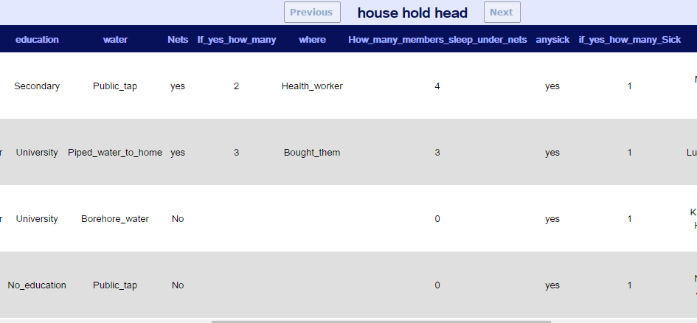

3.1.1 Factors that cause malaria infections
Numerous factors were given that cause the epidemics in the area of our scope and they are the factors;
- Not sleeping under Mosquito net
- Staying near stagnant water bodies
- Staying forested areas
- And more drinking un boiled water
- And also beaten by mosquito bites that transmit malaria.
- Sharing beds with an infected person.

3.1.2
How to prevent Malaria
Spraying a home with insecticides, keeping skin covered at peak mosquito times, using topical insect repellents and sleeping within the protection of mosquito nets all help prevent malaria, explains Mayo Clinic. The drugs that are used to treat malaria can also be taken to prevent the initial malaria infection.

Malaria is caused by a parasite, says Mayo Clinic. The disease causes repeated bouts of fever and chills. Other common symptoms include profuse sweating, vomiting, diarrhoea and headache. Malaria is a dangerous disease that causes severe complications such as organ failure, brain damage, coma, severe anaemia and breathing problems. Milder forms of the disease can persist for years and cause occasional symptoms

3.1.3 DISCUSIONS
Drugs used to treat malaria include chloroquine, quinine sulfate, mefloquine and hydroxychloroquine, Mayo Clinic states. Which drug is most effective varies by region, since malaria evolves resistance to many of these medications fairly quickly. It is most common in tropical and subtropical climates including south of the Sahara Desert in Africa, Haiti and India. It is normally spread by mosquitoes, but it can also be spread through blood transfusions and from a mother to an unborn child. Children and travelers who live in regions where malaria is rare face the most danger from malaria infection.

- REFERENCES.
https://www.reference.com/health/prevent-malaria-e8790e7f72f75dbc#
https://www.cdc.gov/malaria/about/disease.html
http://www.malariaconsortium.org/where-we-work/uganda-mainpage.htm
WWW.GOOGLE.COM

